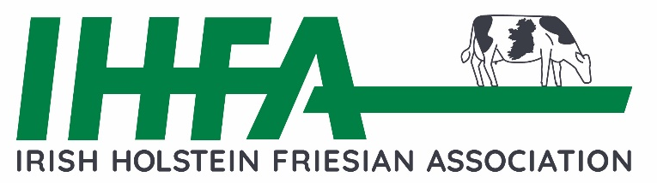
IHFA PREMIER BULL SHOW & SALE

Kilmallock Livestock Mart, Thursday 2nd April 2026

Denis Barrett Auctioneers

Closing Date: Friday 6th March 2026

Live streaming of Sale with Online Bidding facility.
MINIMUM STANDARDS OF ENTRY
- Both the Dam & G.Dam must be classified GP83 or better
- The Dam to have a minimum of 600kgs combined Fat & Protein (total solids in one lact.)
- Dam on 1st lactation (heifers), a minimum of 500kgs combined Fat & Protein will qualify
- Pure Friesian Dam to have a minimum of 500kgs combined Fat & Protein (total solids)
- Pedigree Certificates must be issued for all entrants.
- Age criteria - bulls born before Feb 2025)
- Recommended that bulls should be >150 EBI & Dams 3.5% Protein

PRE-INSPECTION:

All bulls will be pre-inspected before the sale to determine that they are of a Quality standard for a Premier Sale.

All entries subject to approval by IHFA and subject to number of entries.

Entry fee of €200 per animal will be deducted from your account via direct debit and a refund of €100 will be issued on appearance at the sale.

HEALTH REQUIREMENTS:
- All Entrants must be export tested.
- ALL ANIMALS MUST BE BVD TESTED (ANIMAL HEALTH IRELAND NATIONAL BVD PROGRAMME)
- Bulls with clinical signs of infectious disease(s) including Ringworm, Warts, Facial warts, fungal or viral infections will not be accepted for entry.

Postentries to: IHFA, Unit 7, Building C, West Cork Business & Technology Park, Clonakilty Co. Cork or by online form
Email entries to: comahony@ihfa.ie (provide animals tag no, your phone no & any footnotes)
Ownership details will be catalogued in accordance with CMMS data.

We look forward to receiving your entries.

Yours sincerely,

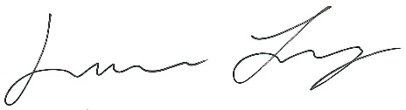

Laurence Feeney
Chief Executive

